*.*



**Introduction to Information System**

**60% Group Coursework**

**Autumn Semester 2023**

|  |  |  |  |
| --- | --- | --- | --- |
| **Group Name:** | | | |
| **SN** | **Student Name** | **College ID** | **University ID** |
|  | **Binod Kumar Thakur** | **NP01NT4A230114** | **23047574** |
|  | **Mukesh Bhusal** | **NP01NT4A230130** | **23048521** |
|  | **Sanidhya Kafle** | **NP01NT4A230107** | **23047402** |
|  | **Sumit Kumar Singh** | **NPO1NT4A230191** | **23047524** |
|  | **Ankit Upreti** | **NP01MM4S230012** | **22085732** |

**Assignment Due Date: Friday, December 29, 2023**

**Assignment Submission Date: Wednesday, January 31, 2024**

**Word Count: 242**

**Project File Links:**

|  |  |
| --- | --- |
| **YouTube Link:** | Keep Unlisted YouTube URL of your Project Here |
| **Google Drive Link:** | Keep Google Drive URL of your Project Here with Anyone in Organization can View Option Enabled |

*I confirm that I understand my coursework needs to be submitted online via MySecondTeacher under the relevant module page before the deadline in order for my assignment to be accepted and marked. I am fully aware that late submissions will be treated as non-submission and a marks of zero will be awarded*

Contents

Introduction 3

1.1 About the coursework 3

1.2 Goals and Objectives 3

1.2.1 Goals 3

1.2.2 Objectives 4

1.2 Use of HTML, CSS, JS 4

1.4 verdict 6

2. Discussion and Analysis 6

2.1 Selected Text Editor -Vs code 6

4. Conclusion 7

# Introduction

# About the coursework

The effective design and construction of an e-commerce website devoted to the selling of Printers and related equipment is the culmination of our first group a is coursework. This project is offered insightful information about designing a basic yet functional e-commerce platform. During the creation are a process, are great effort was taken the to ensure is that the website's is structure are and key navigation is ideas were followed.

The website has a well-structured homepage with material from other pages shown in glimpses. The main attraction is the product page, which features a wide range of Printers goods catered to the demands and price ranges of possible customers. One is additional interesting is feature is a page where visitors can learn more is about the are website designers, provide comments, and the communicate with them. alongside of the authors. To further inform is consumers about technology breakthroughs and their ramifications, a blog is page has been included. A research page also offers information on the sources of inspiration, which are reference websites.

# 1.2 Goals and Objectives

# 1.2.1 Goals

Giving us a thorough knowledge of the ideas and guidelines involved in the creation of an e-commerce is website is the main goal of this assignment. Our goal is to be able to construct a fully operational e-commerce website from the ground up by the end of this coursework. Through practical for experience, we will get the skills needed to create a user interface that is both is intuitive and visually appealing. This includes covering important e-commerce elements is like shopping carts, user feedback sections, and product listings. We will explore creating a user-friendly interface throughout the coursework, making sure it is both aesthetically beautiful and practical.

# 1.2.2 Objectives

An essential component of this coursework is the development of project management abilities, which are especially evident in the process of creating our e-commerce project. We did a the lot of research and consulted a number of a current e-commerce websites to

determine which e-commerce platform and technology would be best for our project. We were is able to choose the technological stack that best fits the needs of our project by using this strategic approach.

HTML, CSS, and JavaScript were used in the creation of the website's front end. We also made wireframes for every webpage, which served as a visual guide for the design and organization of the site. This practical experience gave us important insights into the functioning and aesthetics of front-end programming in addition to introducing us to its complexities.

# Use of HTML, CSS, JS

Hypertext Mark-up Language, or HTML, is a text-based language used to specify how material is organized structurally inside an HTML file. It provides instructions to a web browser on how to display multimedia content, including text and graphics, on a webpage (Lutkevich, 2020). Contrary to popular belief, HTML is a mark up language that is essential to the creation of websites rather than a programming language.

Cascading Style Sheets, or CSS, enhance HTML by specifying how its content is formatted and styled. CSS serves as a tool to improve visual appeal by styling components in markup languages like HTML and separating text from the site's visual design. It's crucial that HTML and CSS work together harmoniously, with HTML serving as a website's structural foundation and CSS adding to the overall visual appeal of it (G, 2023).

Conversely, web developers frequently use JavaScript, a lightweight programming language, to add dynamic interactions to servers, apps, games, and web pages (Jordana, 2023). Its responsibilities include ensuring websites are engaging, functional, and run smoothly.

We used a lot of HTML in our project; it was used to build the website's foundation from the navigation bar to the footer and even the body of the content. A variety of HTML elements, including anchor tags (), paragraph tags (), division tags (), meta tags (), image tags (), table tags (), and

header tags (), line break tags (), and

draw.io), were used to create the website's framework.

We followed the guidelines set for CSS, using all kinds of in order to improve organization and modularity, CSS styles were contained in a separate file that was then connected to the main HTML page. Internal and inline styles were used sparingly depending on the particular needs of the content.

Enhancing website interaction with JavaScript was essential to making it more dynamic and user-friendly. The addition of pop-up notifications, an image slider, and a feedback form were among the key features. Several JavaScript functions were developed and then called with in the code in order to do this.

# 1.4 Verdict

In summary, by demonstrating the use of HTML, CSS, and JavaScript in website creation, the project gave us a more useful and practical grasp of these technologies. Building a website that is similar to real-world e-commerce platforms is a great starting point for our future work. The course's main objective was to familiarize students with the fundamentals of website building, which included how webpages should be constructed, how to improve their aesthetic appeal, and how to include interactive and user-friendly components. Throughout the website creation process, it highlights how crucial it is to know which tools to use, how to use them, and when to use them. Having this information is essential for making websites better and eventually going into web development.

# 2. Discussion and Analysis

This part includes the concept of the text editor that is used, tools that we used while making thes website in development process, and the how wireframe for specific webpages are created the and explained.

# 2.1 Selected Text Editor -Vs code

Vs code was used for the website's development. It is really simple to use when compared to other text editors. Its versatility allows it to accommodate a wide range of file formats, such as HTML pages (.html), CSS (.css), and Javascript (.js). Thus, we were able to avoid using separate editors for every kind of file. Consequently, we can read, modify, and create many file types with only one program, which makes it an extremely helpful tool. It makes it simpler to discern between regular text and various tags by displaying different colours for distinct tags used in development, such as <head>, <img> tags in red, and <href> tags in purple. The picture of the excellent text editor below shows How different colour schemes help us identify different tags and attributes.

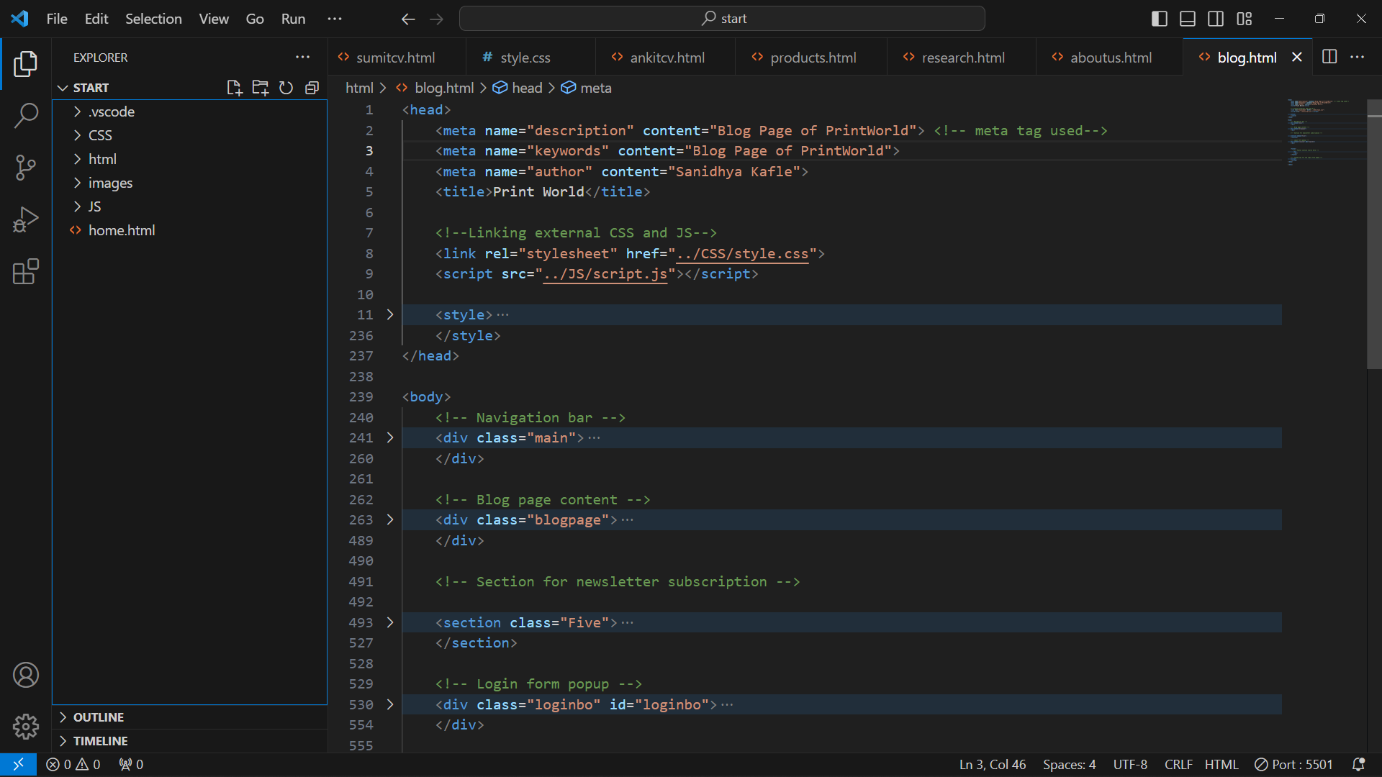

*Figure1:Vs Code*

# 2.2 Tools used for developing wireframes- Balsamiq Wireframes

Balsamiq is the most straightforward tool for design work, and it's a very user-friendly program. It functions is similarly to applying pre-made graphics and shapes to a canvas, making text editing simple and tailored to our needs. This program is very accessible since it does not require any prioris expertise. Alsamiq, which is mostly used to create website blueprints, makes the design process easier by providing pre-designed features are like buttons, photos, search bars, messages, and more. Before the coding stage, Balshamiq-generated wireframes provide an overview of the design of our website.

2.3 Home Page

Our e-commerce website's homepage acts as the first page that visitors see when they open the site, providing a first impression. Its crucial function is to quickly and clearly convey the website's goal. The main page compiles information from every other webpage that is connected, giving a thorough rundown of all the site has to offer. It has a navigation bar with five links to different pages on the website, making it simple to visit different areas. Furthermore, connections to ShutterChunks' social media accounts are incorporated in a footer, which improves audience engagement and connectedness.

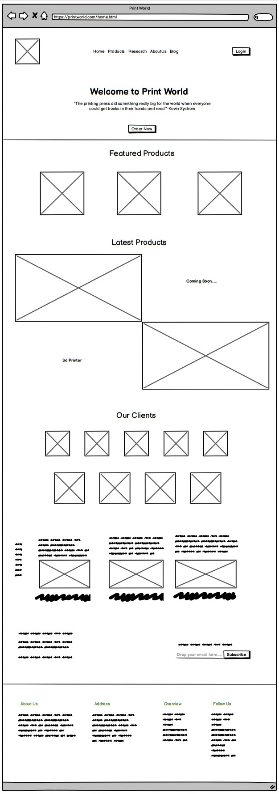

# 2.4 Product Page

Our online store's product page provides a detailed inventory of every product that is offered, along with important information such product names, photos, real pricing, special offers, and more. JavaScript-powered interactive features, such as buttons for actions like "Buy Now" and "Add to Cart," are incorporated into the website to improve customer experience and streamline the purchasing process. From this page, users may accessis the product description page, which includes comprehensive details about each product. The product page has a navigation ba r and footer that match the homepage to maintain consistency with the overall website design, making for a seamless and user-friendly browsing experience.

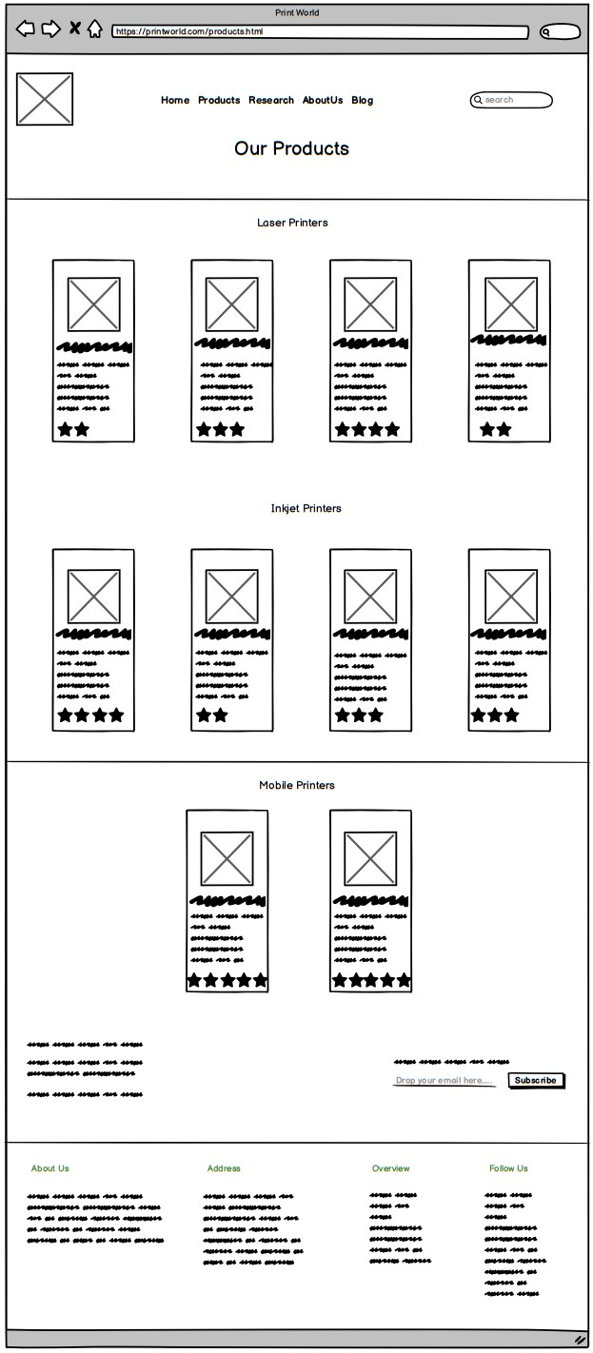

# 2.5 Blog Page

This article isexamines the divergent effectsis of technology in the modern world, including both advantages and isdisadvantages. For continuity and convenience of isnavigation, it keepsis the same footer and navigation bar as the homepage.

# 2.6 About Us page

This particular homepage has a feedback area where users may leave their opinions along with comprehensive information about each member of the team. Pop-up messages are implemented using JavaScript in response to user activities. The platform also provides consumers with access to individual resumes, providing them with further details about each member of the team. This page has the same footer and navigation bar as the homepage to maintain consistency with the overall website design, making the user experience cohesive and easy to use.

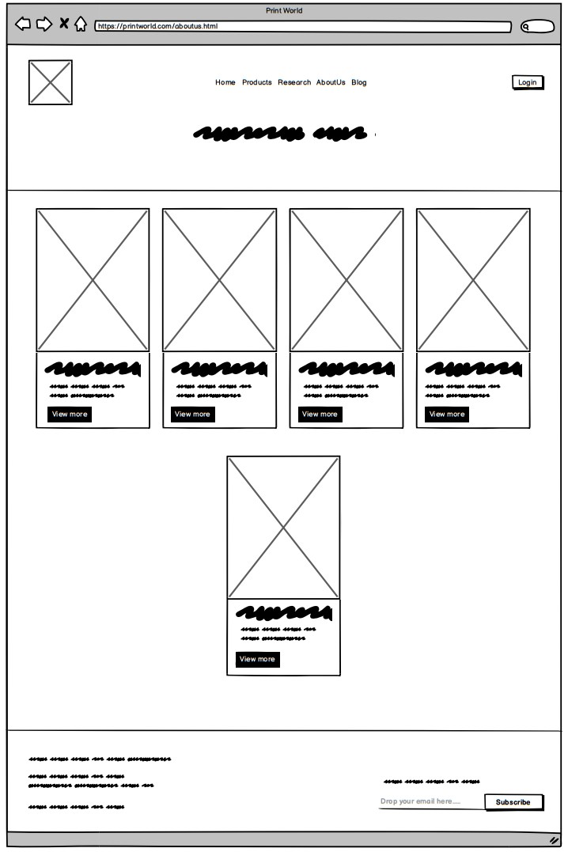

# 2.7 Research Page

Our website's research pageis shows how our built site differs from the reference website, emphasizing the information we added and the parts we took from the reference. Using the same footer and navigation bar as the homepage, this dedicated webpage offers a logical and intuitive browsing experience.

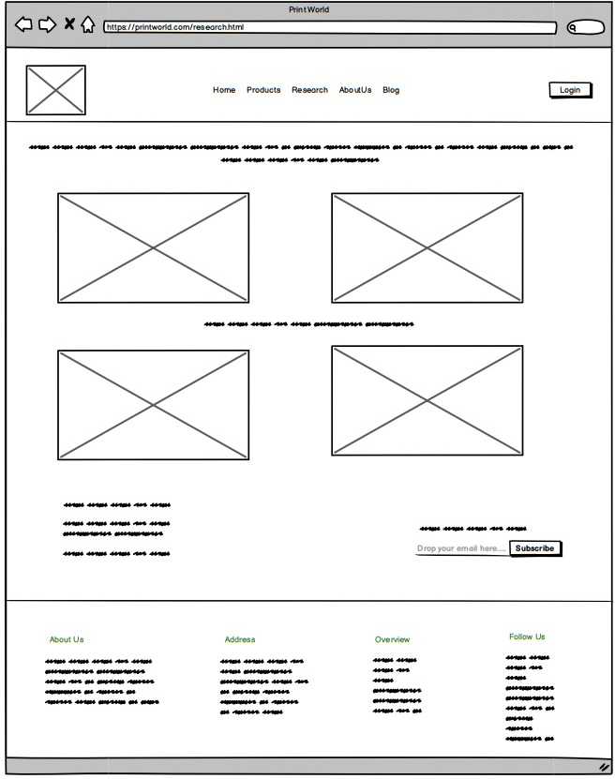

3. Testing

Testing determines whether the work performed is functional and accurate or not. It

determines whether we followed the provided guidelines while doing our task or not.

The clarity of the work could be evaluated by testing it. In order to assess whether the

completed project satisfied all the requirements or not, several tests should be

performed in this project as well. A total of five tests are performed, three of which are

JavaScript tests, one of which is Nav bar hover testing, and the final one is external

link testing.

# 3.1 Test1 : Products-Popup [JavaScript]

|  |  |
| --- | --- |
| Objective | To check products details popup. |
| Action | When you click on the products the products detail’s popup should be visible and to remove it click outside of the products’ details. |
| Expected Result | Products’ display should be popup. |
| Actual Result | Products’ display is popped up. |
| Test | Successful. |

*Table1: product-popup*

The screenshot below is the product categories listed. 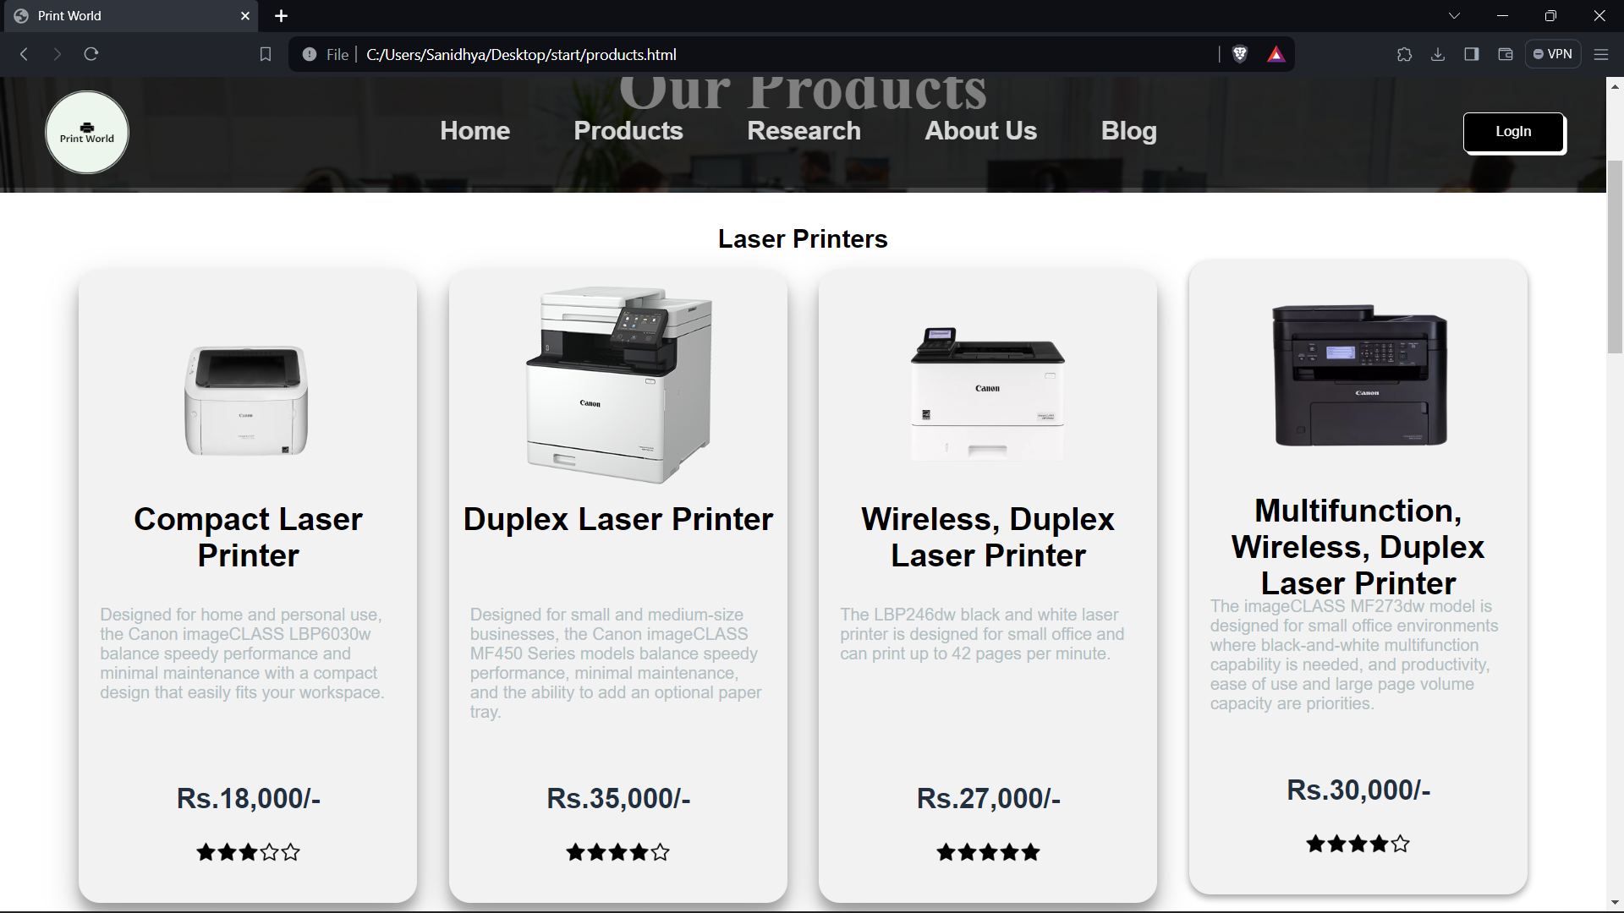

*figure1: Screenshot of the product page*

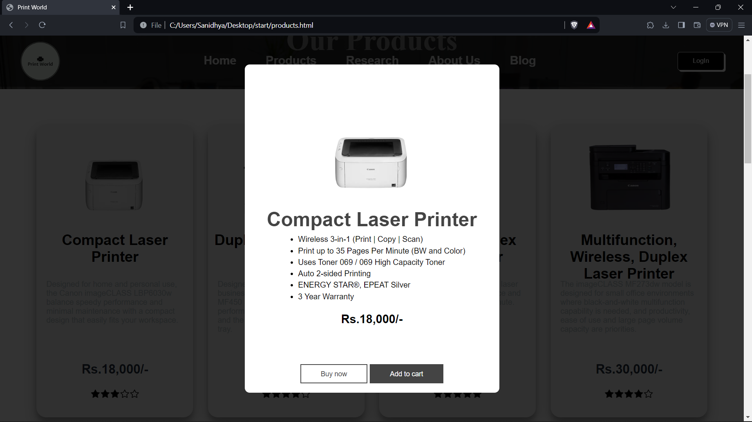

*figure2:Screenshot of the product-popup*

# 3.2 Test2 : Alert popup[JavaScript]

|  |  |
| --- | --- |
| Objective | To check alert popup. |
| Action | When you click on the add to cart or buy now of the products alert popup should be visible at top of the website. |
| Expected Result | Alert should be popup. |
| Actual Result | Alert is popped up. |
| Test | Successful. |

*Table2: Alert popup*

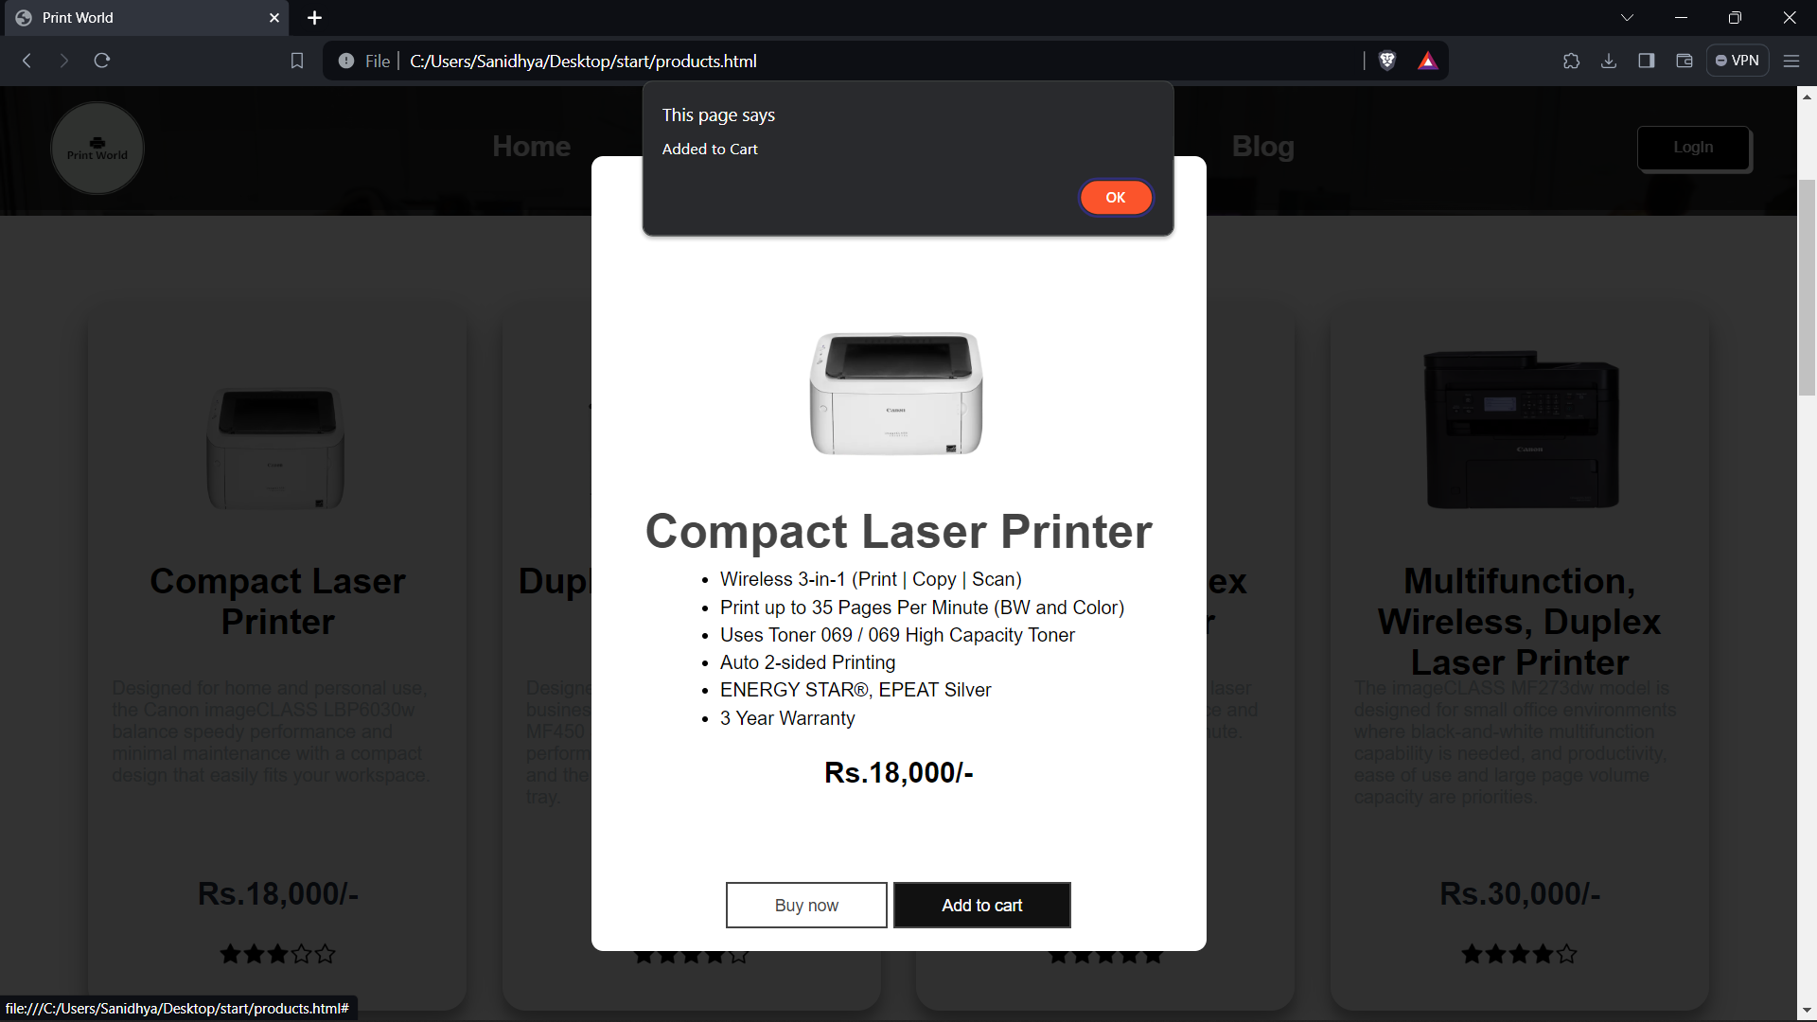

*figure3: Screenshot of the alert popups*

# 3.3 Test 3 : Form Validation [JavaScript]

*Table3: Form Validation*

|  |  |
| --- | --- |
| Objective | To check if form validation pop-up alerts are working or not. |
| Action | All the required fields were filled at first and Submit button was clicked and then some fields were left empty and Submit button was clicked. |
| Expected Result | “Empty fields are found. Please fill all the fields...” -This message should be displayed at first and then “Thank you for your valuable feedback!!!” -this one should be displayed. |
| Actual Result | “Empty fields are found. Please fill all the fields...” -This message was displayed at first and then “Thank you for your valuable feedback!!!” -this one was displayed. |
| Test | Successful. |

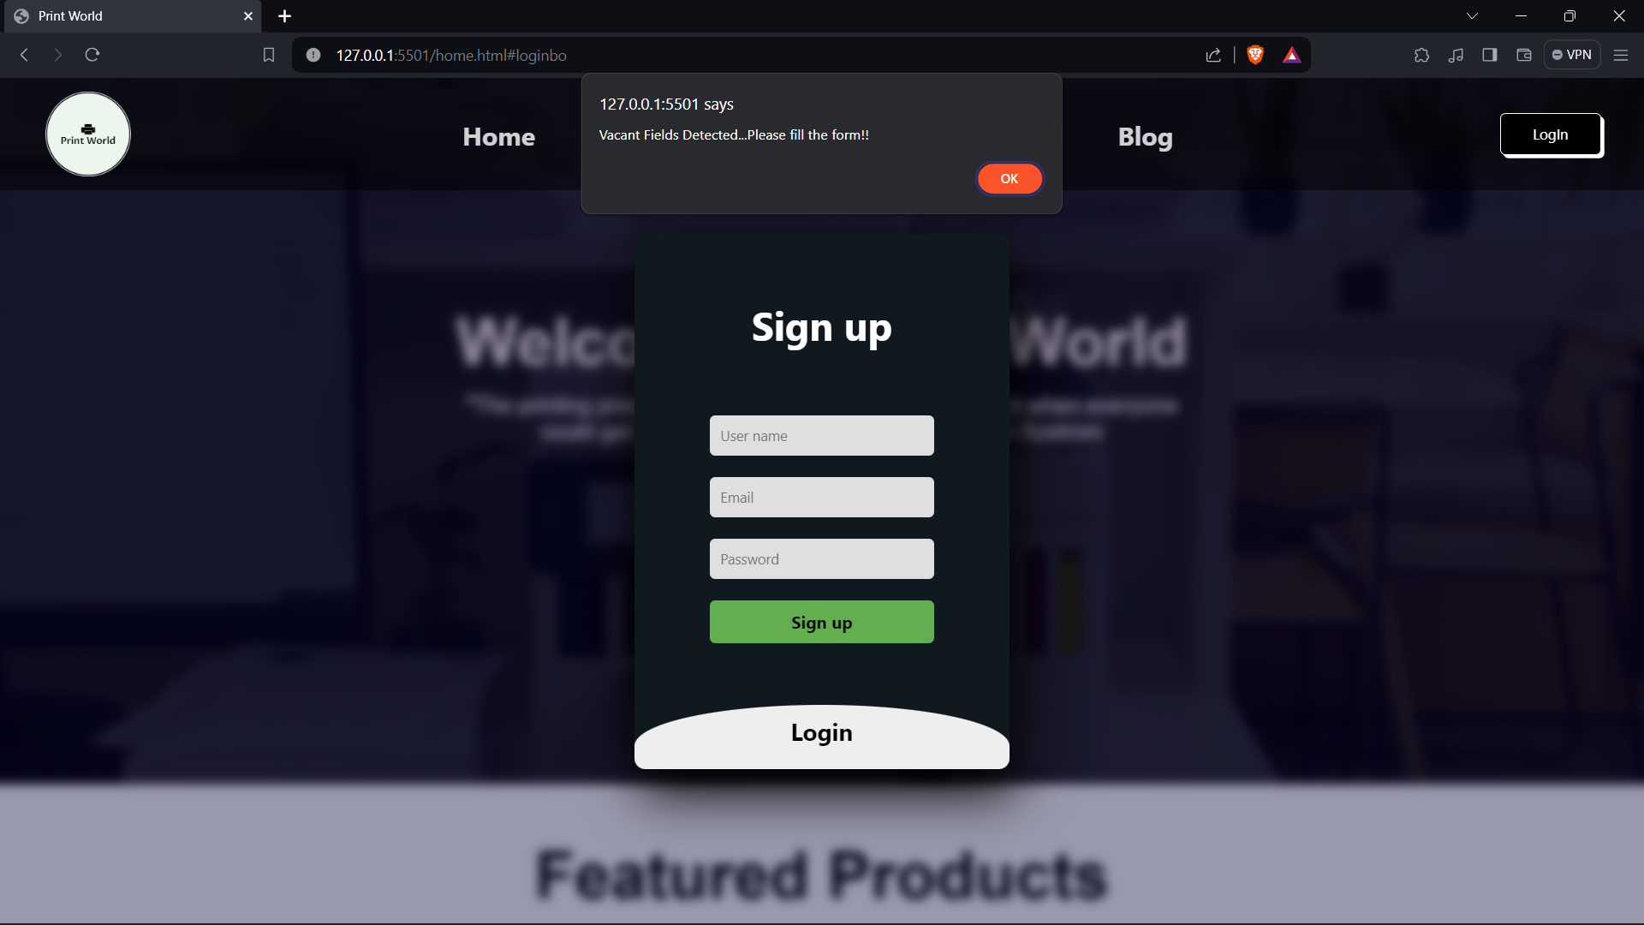

*figure4: Screenshot of login page with vacant fields.*

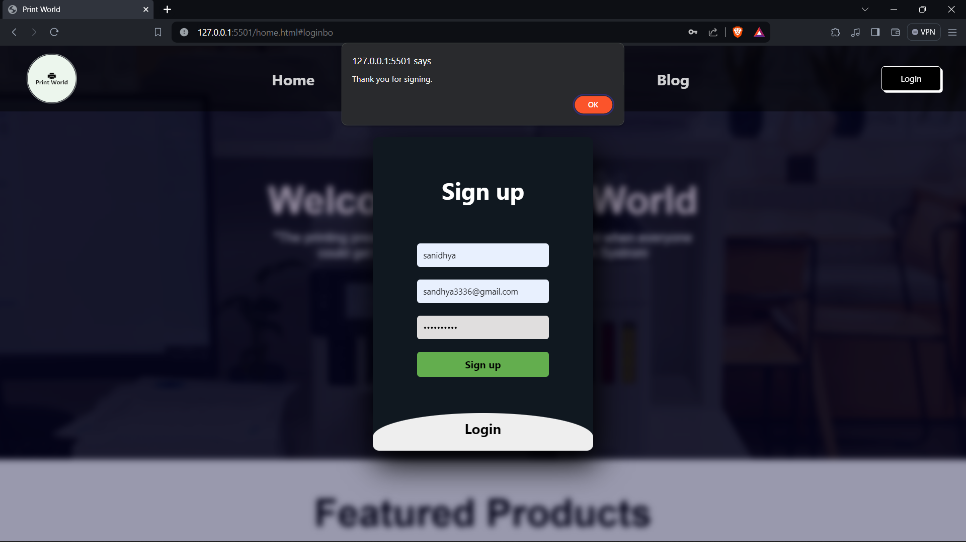

*figure5:Screenshot of loginpage after entering value.*

# 3.4 Test 4 : Nav Hover Effect Testing

|  |  |
| --- | --- |
| Objective | To check if form validation pop-up alerts are working or not. |
| Action | Checking the hover on the navigation bar. |
| Expected Result | The word on the nav should be bigger and get highlighted than other ones when cursor is pointed. |
| Actual Result | The word on the nav got bigger and got highlighted than other ones when cursor is pointed. |
| Test | Successful. |

*Table4: navigation hover*

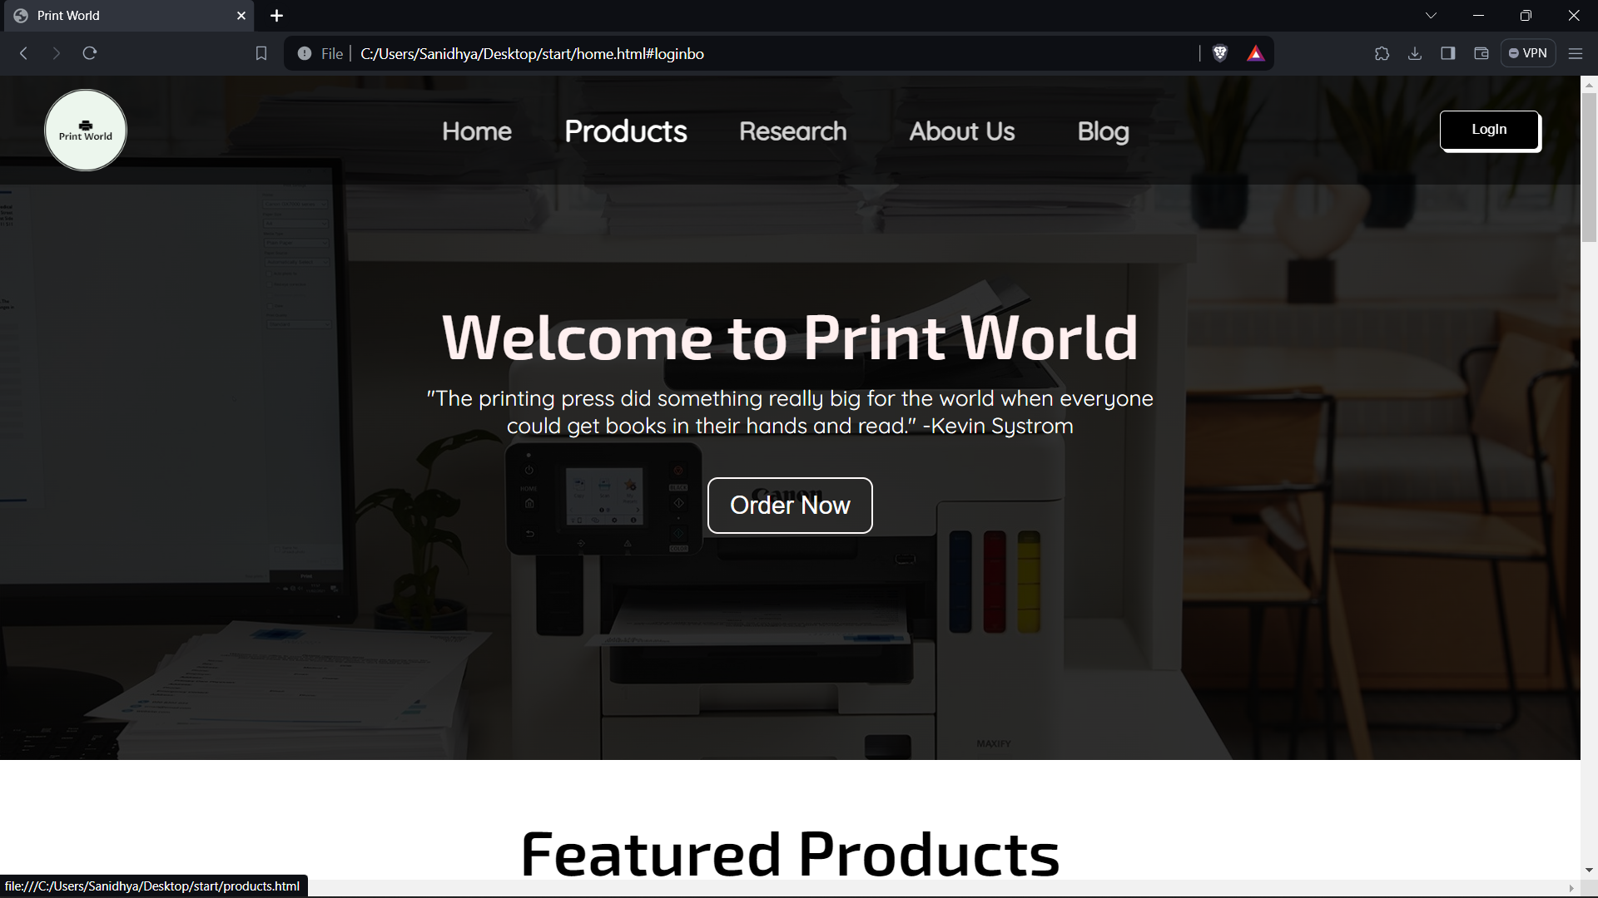

*figure6:Screenshot of navigation hover*

# 3.5 Test 5 : Link Testing[Internal and External]

|  |  |
| --- | --- |
| Objective | To check if external and internal links are working or not. |
| Action | External and internal links were clicked. |
| Expected Result | External link should open the respective website whereas internal link should open the expected webpage within the website. |
| Actual Result | External link opened the respective website whereas internal link opened the expected webpage within the website. |
| Test | Successful. |

*Table5:Link testing* 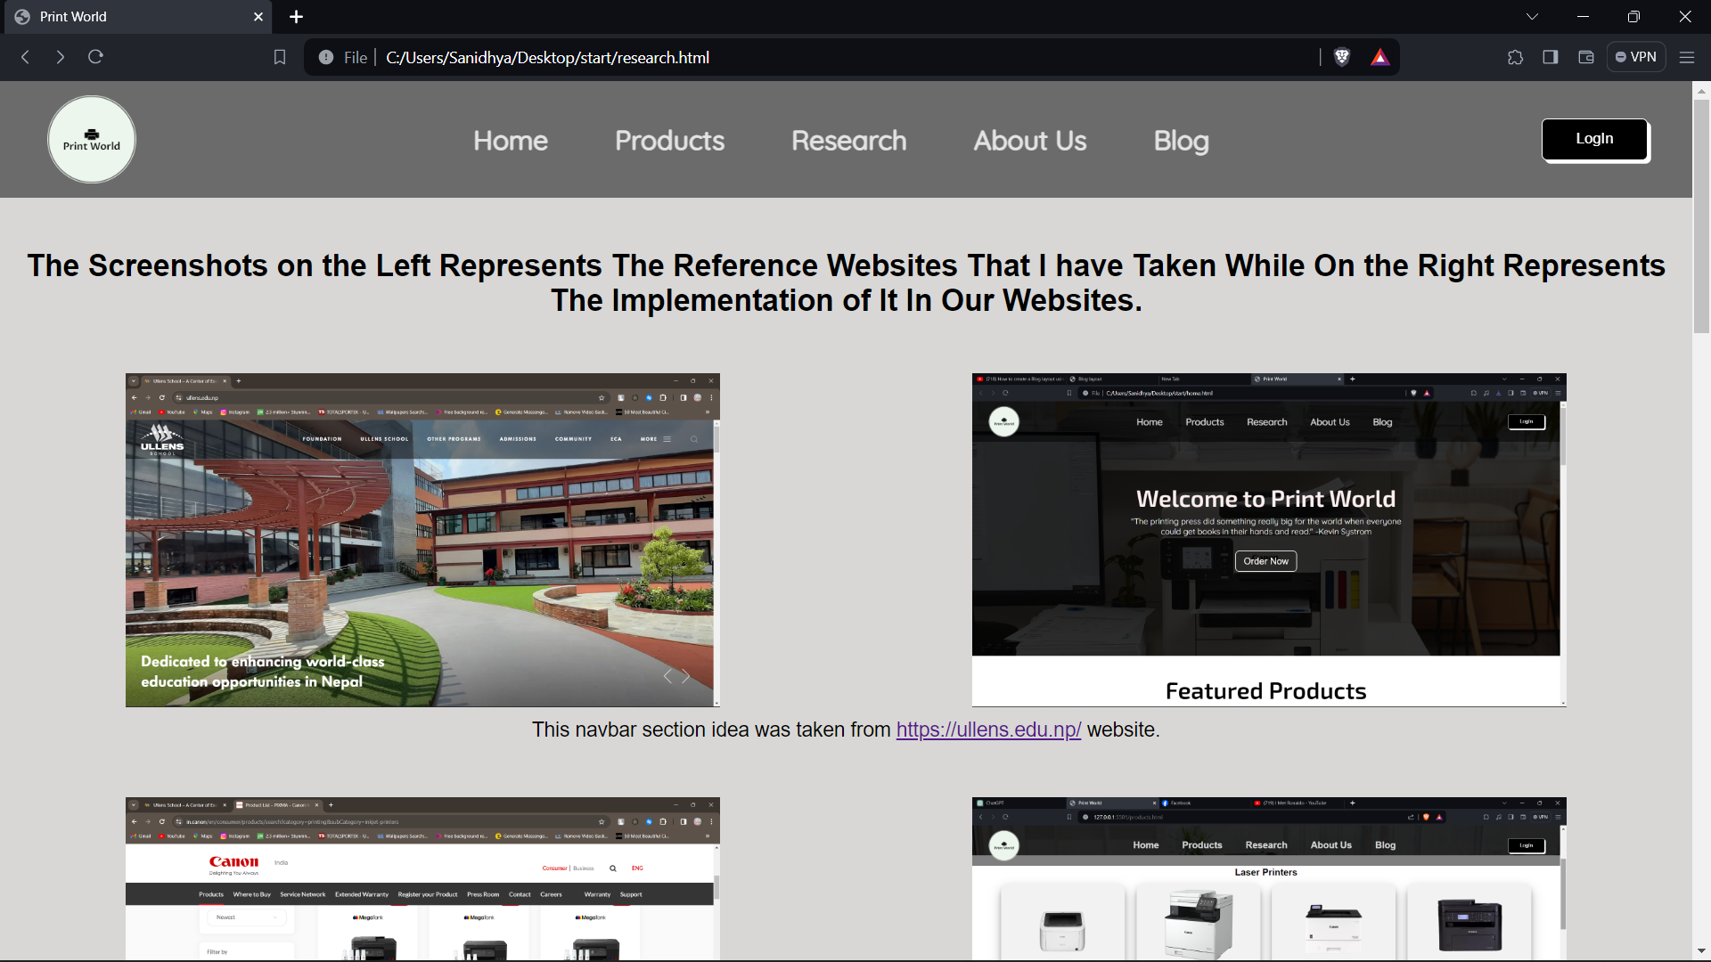

*figure7:Screenshot of website using external link*

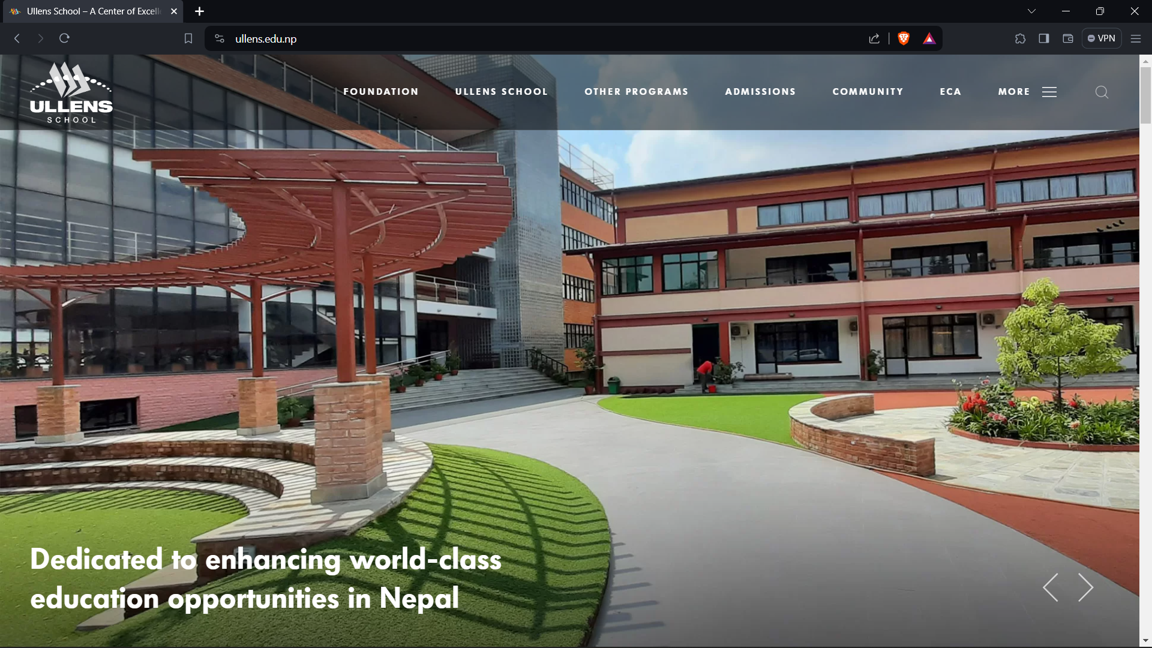

*figure8:Screenshot of entering in external link*

In the internal link we are going from home page to product page

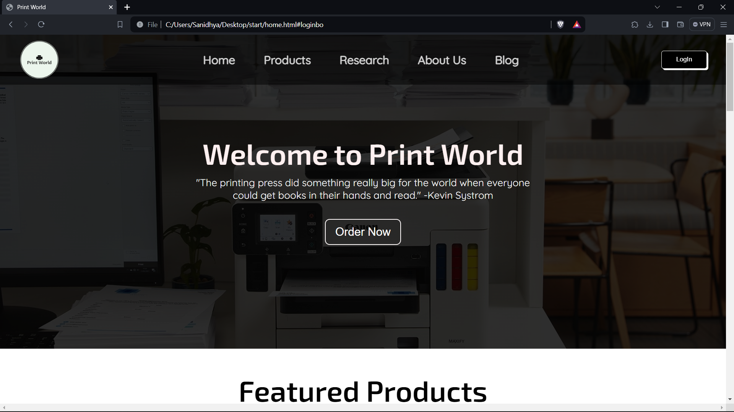

*figure9:Screenshot of Website before clicking in internal link*



*figure10: Screenshot of product page after clicking products in navigation bar*

# 4. Conclusion

I would want to talk about a few topics after completing this curriculum. since we were allotted a 60% weighted major group information system coursework. We developed each webpage's wireframe using Balsamiq Wireframe, utilized MS Word for documentation, then coded the majority of the pages using vs code Text Editor.

For our homework, we employed three key languages: HTML, CSS, and JS. HTML provided the website's structure and content, while CSS enhanced the website's aesthetic appeal. Javascript also brought websites are to life by allowing users to interact with them.And the greatest part was that while creating this curriculum, we learned about a ton of technologies that is we had no idea existed. Learning new things has always been our specialty. Writing code was a difficult chore, and vs code Text Editor was used for much of the coursework. We have never before worked on a webpage that is a teacher has assigned to us.

The most difficult part for us was filling out the form validation, which was something we had to have on our website. Despite our best efforts to double-check, we were unable to receive alert messages, but with the assistancethe of our teachers and a reference to the appropriate instructions for the coursework, we werea able to successfully finish the assignment. As soon as we completed developing the code, we started working on reporting. Reporting was, to be ishonest, considerably easier, but it also required a lot more time and effort. Evidence the work completed, i.e., relevant screenshots of the work completed, had to be included. This was a challenging procedure for us since we had to identify and find the correct screenshot among a number of different ones.

We gained a lot of isknowledge about html, css, and js coding. Even capital and lowercase letters might have a significant impact, as the javascript code demonstrated to us. We gained a great deal more familiarity with these languages than we did during our instructional sessions.

The reporting segment taught us how to do any assignment accurately and peacefully. It also made us realize that no matter how difficult the task is, it can be finished if we adopt a never-give-up mindset and patience In summary, this coursework is now complete, and because we learnt a lot from it, we feel a bit morethe comfortable utilizing HTML, CSS, and JS. We now possess a strong foundation in all three languages to a certain extent, which will be useful for our future projects. This curriculum has taught us a lot, and we are eager to apply what we have learned to tackle challenging programming challenges